1. Original Data: C:\Users\a\Documents\Project\Clean_Test\bkup
2. We have created .csv files for each equipment as per C:\Users\a\Desktop\APMS Nihal & Ashutosh\Documents\RCS Signals with Equipment Name_INS Sunayna_Segregated.xlsx. In this file all the channels which equipment is using is mentioned.
3. Then tables of all equipment were created in the mysql database.

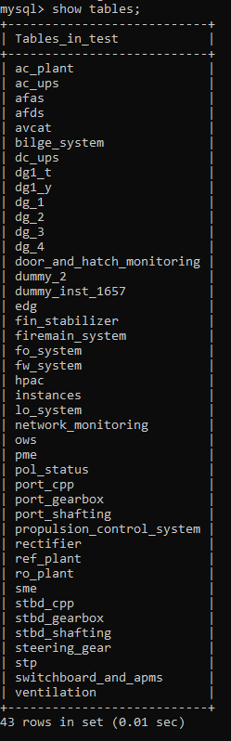

1. We were working on DG1. So, below files have work regarding that equipment only.
2. We found 20 channels which had the same values(ie. identical channels) or channels having only one value. So, we dropped such channels from dg_1.csv

Code: C:\Users\a\Desktop\APMS Nihal & Ashutosh\Malay & Dhruv\Cleaned_Data\Feature_Reduction.ipynb

1. Next, we divided timestamps into 225 instances based on channel 1652. Then checked the duration of all the instances. After plotting the histogram of duration we conclude that we'll discard all the instances which have duration less than 10 min. Eventually we left with 177 instances.

Code1: C:\Users\a\Desktop\APMS Nihal & Ashutosh\Malay & Dhruv\Instance\1652_Instances.py

Code2: C:\Users\a\Desktop\APMS Nihal & Ashutosh\Malay & Dhruv\Instance\1652\Instance_plot.py

Code3: C:\Users\a\Desktop\APMS Nihal & Ashutosh\Malay & Dhruv\Instance\1652\Histogram_Duration.py

Img: C:\Users\a\Desktop\APMS Nihal & Ashutosh\Malay & Dhruv\Instance\1652\1652_Histogram.png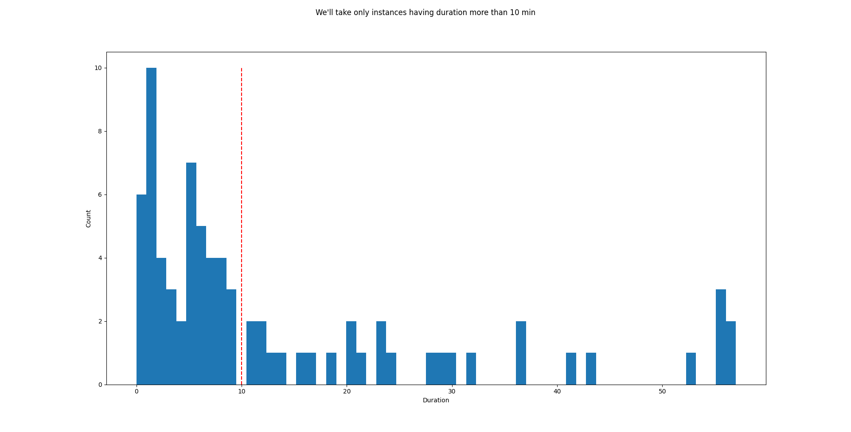

1. Now, on remaining channels we'll check if the minimum value of the respective channel is present in instance or not. If present then mark it as 0 and rest as 1. Then, for each channel we have checked 0's count and 1's count.

Code1: C:\Users\a\Desktop\APMS Nihal & Ashutosh\Malay & Dhruv\Instance\ch_labelling_instance.py

Code2: C:\Users\a\Desktop\APMS Nihal & Ashutosh\Malay & Dhruv\Instance\instance_count.py

1. After plotting timestamp vs channel values. We have selected particular instances(which have ‘off’ value followed by ‘on’) of Ch1780 and we'll predict the TTF(Time to failure) value of those instances only.

Code1: C:\Users\a\Desktop\APMS Nihal & Ashutosh\Malay & Dhruv\Instance\Histogram_Hist1.py

Code2: C:\Users\a\Desktop\APMS Nihal & Ashutosh\Malay & Dhruv\Instance\1652\Model\TTF.py

1. We filled NULL values on path1 file and saved file in path2.

Code:C:\Users\a\Desktop\APMS Nihal & Ashutosh\Malay & Dhruv\Instance\1652\Model\Data Preprocessing.ipynb

Path1:C:\Users\a\Desktop\APMS Nihal & Ashutosh\Malay & Dhruv\Instance\1652\Model\1780_TTF.xlsx

Path2: C:\Users\a\Desktop\APMS Nihal & Ashutosh\Malay & Dhruv\Instance\1652\Model\1780\Dataset.csv

1. After filling missing values we trained 2 models to predict TTF.

Code:C:\Users\a\Desktop\APMS Nihal & Ashutosh\Malay & Dhruv\Instance\1652\Model\Model_Building.ipynb